Day1

Problem 1

1. Run the container hello-world

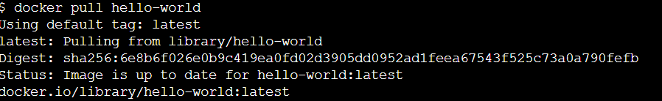





1. Check the container status



1. Start the stopped container





1. Remove the container

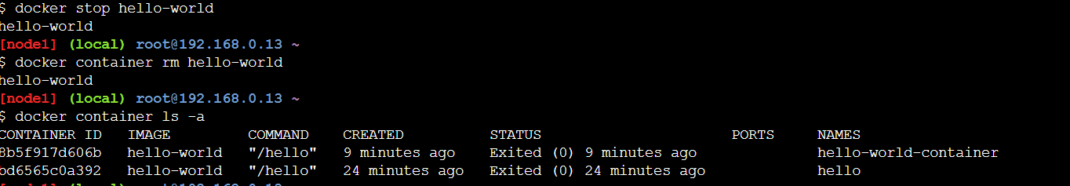

1. Remove the image

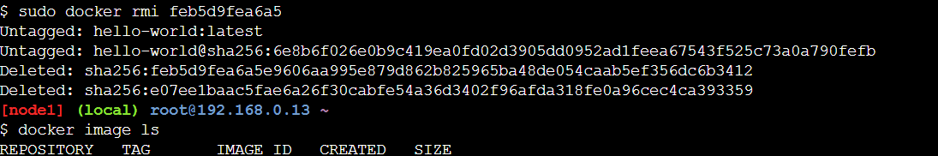

Problem 2

1. Run container centos or ubuntu in an interactive mode

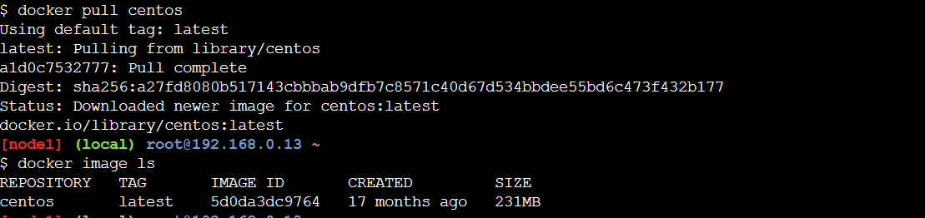 



1. Run the following command in the container “echo docker ”

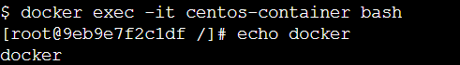

1. Open a bash shell in the container and touch a file named hello-docker​



4-

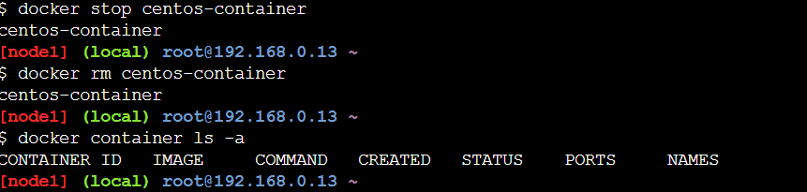

* 5- Remove all stopped containers​

